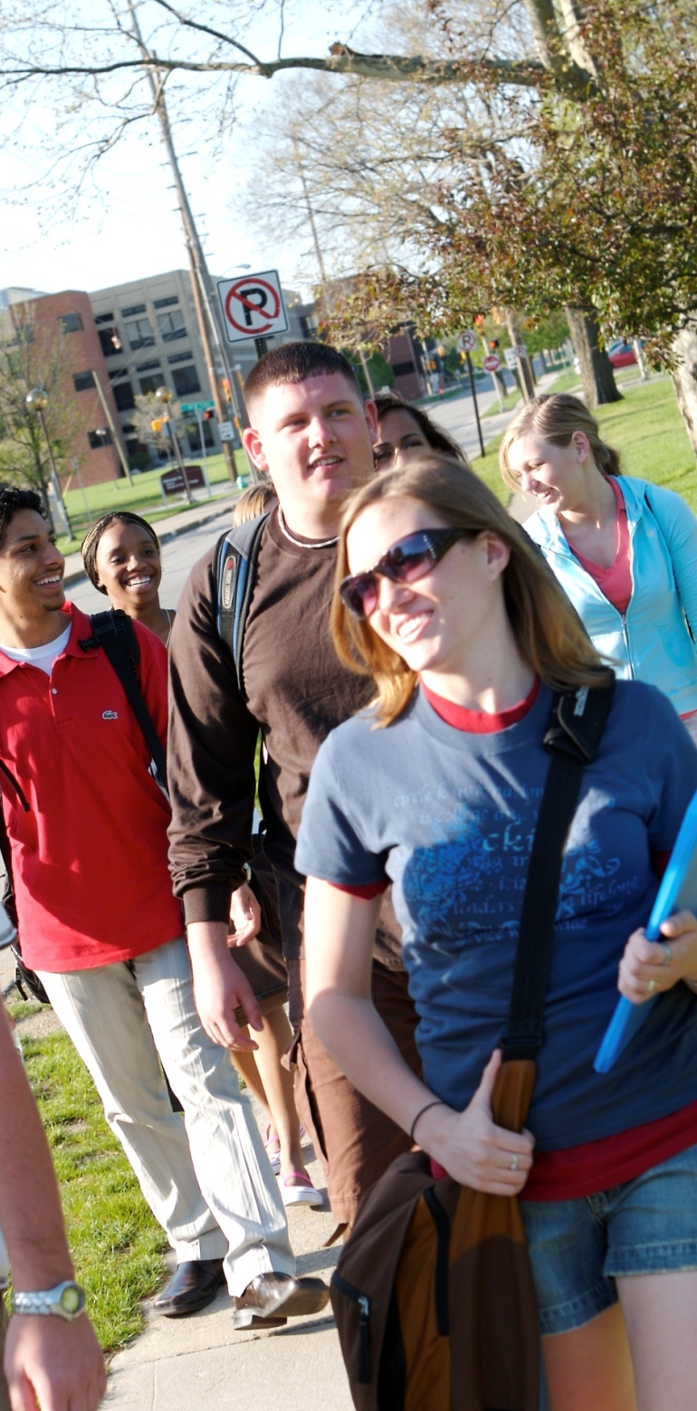
For more info, check out our website @
Upcoming District Events

[Club website]

Fall Membership Rally
October 15-16

Total K Day
[To be announced]

District Convention
February 18-20

Spring Officer Training Conference
March 18-20

Meetings

When:
[Date, time, how often meetings are held]

Where:
[Location]

What:
[Potential activities done during meetings]

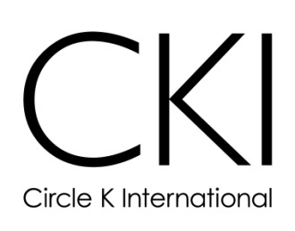
Questions?
Comments?
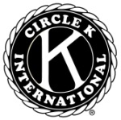

Concerns?

Welcomes
A Kiwanis-family member

3636 WOODVIEW TRACE
INDIANAPOLIS, IN 46268 USA
1-800-KIWANIS
[Contact info (name, position, email address)]
YOU!


How to Join
Join

- Dues: [your club’s membership dues]
- Minimum membership requirements: [if your club has them, list/explain each requirement]

What is CKI?

CKI is the world’s premier collegiate service organization that promotes…

Service

The world’s largest collegiate community service organization
[The core of Circle K International is service, more specifically service to the children of the world. Many of our service events seek to aid the children in our community, whether it’s donating books, tutoring local students, or preparing holiday gifts. Some of our upcoming service projects include [LIST A FEW OF YOUR CLUB’S FAVORITE PROJECTS]]


Love to Serve
Leadership
Fellowship
Live to Serve
[A strong network of friendships is the foundation of Circle K International. We continue to expand and strengthen our network through various social events.]
[Circle K International also aims to develop members’ leadership skills. Numerous opportunities are offered in the club, district, and international level to encourage members in realizing their service leadership potential.]

